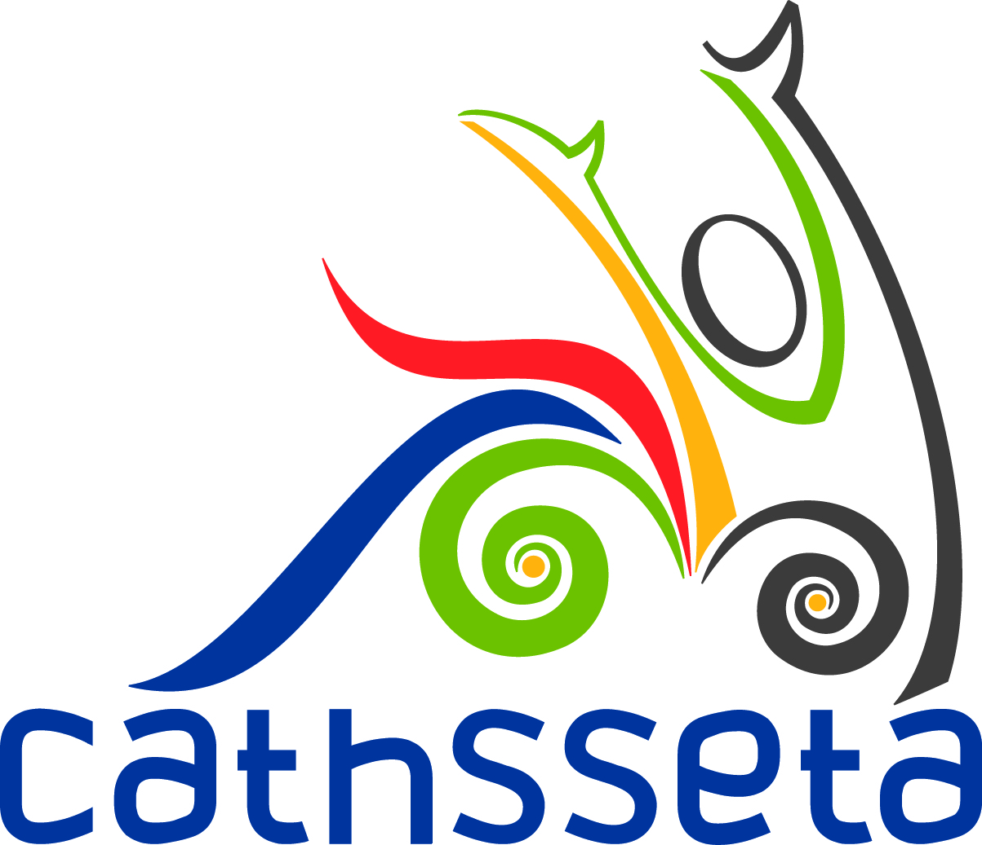
VACANCIES
Culture, Arts, Tourism, Hospitality and Sport Sector Education and Training Authority (CATHSSETA) is a Sector Education and Training Authority (SETA) established under the Skills Development Act (No 97 of 1998). Applications for the advertised positions listed below are hereby invited from suitably qualified persons.
- Administrator to the Chief Financial Officer – CATHS11/2022
- Board Secretary – CATHS12/2022
- Analyst: Research and Planning – CATHS13/2022
The prospective applicants are to note the following:
Kindly refer to the CATHSSETA website for the complete Job Specifications and full Terms & Conditions on the following address: www.cathsseta.org.za.
Applications are to reach CATHSSETA by 16h00 on Tuesday, 07 June 2022 for the position of Administrator to the Chief Financial Officer and Analyst: Research and Planning and on Friday, 10 June 2022 for the position of Board Secretary.
Any applications received thereafter will be disqualified and not considered.
Any queries may be directed telephonically to the Human Capital Management and Development Department, Ms. N. Xhalabile on (066 495 1014)

